Triathlon London
(Triathlon England - London Region)

Minutes of committee meeting held on 5th September 2017 at 7pm.

Venue: YHA London St Pancras, 79-81 Euston Rd, Kings Cross, London NW1 2QE

Committee members present: Debbie Clarke, Audrey Livingston, Jon Train,
Joe Wilson, Alan Spelling, Nicola Dennes, John Lunt, Martin McGuigan

Advisors in attendance: Tom Chant, Andrzej Warhaftig

Apologies for absence: Chris Hall, Peter Lambert, Donna Dewick

- Review of previous minutes
No comments
- Reports
Each committee member provided a verbal update outlining the key themes from their report. For detailed reports, see appendix 1.
MM noted that junior results at the IRCs were not quite as good as had been hoped; potentially due to current difficulties finding draft legal and/or open water races in London.
AS mooted the possibility of a drafting race at the London tri, and JL has offered his closed road venue to British Triathlon.
In addition, the Southern regions seem to have a greater depth of talented athletes.
It was noted that the Trinity event is always well attended, particularly by those who compete only in the Trinity event each year. MM noted he would look into what they are doing to encourage these ‘’one off’’ competitors.
On the whole, participation has been steady, but not exciting, and the events have been reasonable well run.
JL queried the consequences (in terms of better utilisation of time, money & resource) of not entering the IRCs.
JT noted that a review of junior regional competitions is currently being undertaken by the ‘’Centre’’.
AL discussed the progress she has made leading after-school clubs, particularly at Dulwich. Looking to get into more schools, and will provide links to regional clubs if juniors show an interest.
AS discussed the senior league. Overall a successful season, with the exception of getting results from the most recent race. Currently working through the issues.
AL organised a workshop lead by James Dunne of Kinetic Revolution with a focus on run technique. Initial worries that the cost to participants would be prohibitive, but it has sold out.
Consider circulating a questionnaire at the AGM asking attendees for views on courses they would like to see.
- Awards evening
A few responses have been received already, and ND asked the committee to forward the invite to their contacts.
Aiming to publish winners/results on the Tuesday after the London Fields race.
Awards to start at 3pm, with Steve True again offering to help. AS to present volunteer award.
Various sponsors will be in attendance, and the committee are to consider potential future sponsors who could be invited along to get a picture of the region ‘’at work’’.
To date nominations have been received for all categories except young volunteer, and technical official. A reminder email is to be sent out ahead of the voting deadline of Thursday.
DC queried whether we could push the regional deadline back to the end of the month by using either the central system, or another method.
It was decided that the best option would be for DC to email club chairs after the national nomination deadline on Thursday to ask for further nominations at a regional level, and provide a physical form for completion.
A point to feed back for next year is to request a longer nomination period nationally.

- Governance review
AS and a sub-committee have spent a considerable amount of time reviewing the constitution, identifying potential issues, and proposing amendments. Each committee member has been approach, and asked to provide feedback.
It was noted that the proposed will be presented at the AGM. Therefore an action point was noted for each committee member to re-review the proposals with a ‘’fine toothcomb’’ ahead of the AGM.
AS noted that there were a number of key requirements for a constitution, and the committee, as follows:
- Strive to achieve values of organisation/membership
- Have a mission – strategic plan for long term stability
- Effective leaders – right balance on committee
- Be inclusive with right recruitment policies
- Understand and comply with legal and committee duties
- Be accountable to stakeholders
- Make all committee fully aware of fiduciary duties and risk obligations
- Ensure open and transparent culture
- Promote in a positive manner
- Be responsible to provide transparency for members and stakeholders
- Be accountable and allow organisation to be held accountable
- Disclosure is ‘’pivotal’’
- Publish publicity, make available to members allowing for proper scrutiny
- Be prepared to deal with formal complaints and disputes from members
- Act with propriety – benefitting reputation
- Responsible for any competitions – must be fair, robust and compliant with rules
- Must have a robust conflict of interest policy
- Must have confidentiality on committee matters and respect decisions made in committee even though they may conflict with personal views

- Committee rotation & roles
DC noted that when a member stands down, a lot of experience can be instantly lost. It therefore would make more sense to have a 3 – 6month hand over period, in order that this experience is passed on.
The term of service is currently limited to a maximum of three years, plus another three should there be no other willing candidate. The committee discussed increasing the term to 4 years, plus another 4 against an increase to 4 years plus another 2, then a further 2.
It was noted that each committee member stands down at the end of each year, and is re-elected. Therefore, it was considered that at 4 + 4 term would not be inappropriate.
AW noted that all changes are required to be ratified at the AGM. Although standard practice is to agree the constitution after the ‘’formal’’ first part of the AGM, it would make more sense to complete this prior to voting on positions. This would ensure there is no embarrassing situation whereby one member resigns due to meeting their 3 year tenure (as currently required), whilst subsequently the position isn’t filled, and the permitted tenure is increased to 4 years. Given the current difficulties in finding multiple candidates for positions, it was felt this would be a prudent approach.
DC noted that so long as the proposal to agree constitutional changes is put to the members prior to the AGM, and the committee are open and transparent about the reasoning for the change to the ‘’standard order’’ or the AGM, no issue with this process is expected. The committee agreed.
Further, it was noted that in a committee member’s final year or service, they should be actively looking for, and training, a replacement.
Spread sheet of currently committee’s tenure to be compiled to understand where each member currently sits.
Specifically regarding roles, social media is currently vacant, and Donna is considered a replacement.
DC queried whether there were any roles we don’t have, but should.
AW noted that his club now has a Medical & Health role, and an increased focus on safety and security (through members being given a scanable band which includes ‘’ICE’’ details).
Committee to ask around to see if anyone would be willing to sit in a similar position on the region. If so, to consider co-opting in year 1 as a trial.
- GDPR
DC noted that once the GDPR rules come into effect, there will be a personal obligation on the committee if a breach occurs.
Each member is to think about the data we hold, and the risks involved in order to carry out a detailed review.
DC will also speak to the club chairs, and arrange a meeting to go through the requirements (once Centre have provided some guidance).
- AOB
AS noted that no recent minutes appear on the website. JW and JT to liaise to arrange publication.
AS noted that recent documents being produced by TE are neither dated, nor signed, which is poor practice. To be fed back to TE.
Strategic plan should be presented to membership. It was considered the best option for this will be to send out a copy post AGM, once the plan for the next few years is put together by the newly elected committee.
Consideration of rooms for AGM between ISEH and the Quaker meeting house in Euston.
JT noted coach ed courses are not currently filling. Asked the committee to push people towards them if possible. To bring this point up at the AGM as it is a cost to the ‘’Centre’’.
- Next meeting 8th September 2016.
A pre-AGM call will be held Monday 25th September 2017 at 7.30pm to discuss the AGM process.
AGM will be 17th October 2017

Next committee meeting agreed at 14th November 2017. Location tbc.

Appendix 1: Reports
Report from Debbie Clarke
Chair report
August 2017

- Constitutional changes
The new Code for Sports Governance was launched by the Government in October 2016 with details of its content only becoming available this year (as previously forwarded to the committee). On the back of this Triathlon England has had to amend its constitution. If you have read Bill James comments on the website it is well worth it. If TE do not adopt the code then they will not be eligible to apply for UK Sport funding in the future.
https://www.triathlonengland.org/news/the-new-code-for-governance-and-what-it-means-for-triathlon-england_7690
But what does this mean for us? A couple of things.
Firstly the constitution has changed some of the roles of the Council (to which we are part). This is because the governance structure within the code requires separation of management and oversight. The council is an oversight group to ensure the members interests within the sport are being protected when decisions are made by the board. In reality the board has had most of these roles for some time but the council did have rights for example to sign off TE budgets. Council will now get the ability to review and query (which it does now) but sign off will be by the board.
Secondly certain elements of the new code will trickle down to the regions and there will be a requirement at some point for us to ensure our own constitution is in line (as much is appropriate and possible). As such Alan has lead a sub group to look at proposed changes which he will present to the committee when we met. This will at some point also move to the clubs so encouraging our clubs to take up ClubMark will help.
The key will be to ensure that there is London representation on the board (through the council appointed representatives) so that we can make sure our members interests are being voiced properly. This year one position becomes available so I have put myself forward to try to ensure we can keep this position as a London Chair one. For the past [x] years it has been help by the Eastern Region.

2. Next TE Council meeting
The next TE Council meeting, which will be held at the same time as the TEMB is on the 10th September this will be the perfect opportunity for me to voice and table any issue the committee has.
Interestingly Bill James has combined the TEMB and Council meetings to ensure transparency and I believe this is his intention going forward also. Council (other than those appointed to the board, as noted above) will only be able to vote on Council issues tabled. This does not stop Council from querying issues at this meeting though.

3. GDPR
The new General Data Protection Regulation (’GDPR’) come into force on 25 May 2018
The basic principles behind GDPR are:
- it makes data protection a fundamental right for individuals – it seeks to put individuals in control of their data by requiring organisations to be much more transparent about what they do with personal data and making it harder to obtain consent;
- it requires organisations to change their culture around data – they must be able to demonstrate compliance not just by issuing policies and procedures, but by being able to show that these have been absorbed into the culture of the organisation and are understood;
- it globalises EU data protection law – the new laws will catch not just organisations based in the EU, but also those supplying products or services in the EU or monitoring individuals located in the EU;
- GDPR backs all of this up with very serious sanctions, including regulatory fines of up to €20M, as well as making it easier for individuals to enforce their rights directly.
We need to think about what information we collate, i.e. league details and ensure we are compliant.
What is the problem for sports clubs? Individuals may have given their "consent" on an opt-out basis (they failed to tick the box that said "no"). Under GDPR clearer consent is required. In addition, even where consent has already been given, such as on an opt-in basis, it may no longer be good enough as "informed consent" is required. Clubs could start asking members for their consent in a GDPR-compliant way over the coming months. I could get some advice on what this could look like.
TE are preparing their advice to clubs but it is not going to be ready for a few months at the earliest. I would suggest we educate the clubs on deadline and give them some initial ideas for what the can do in the meantime. See attached checklist and further information.

4 Provisional dates for next club chairs meeting
Either 2nd or 9th October
Provisional Agenda Items to agree at our committee meeting:
- Governance, should we ask clubmark or a consultant (I know someone from Moore Stephens) to could present?
- GDPR
- Sharing experiences of the year

Report from Alan Spelling
Vice chair report
A very significant amount of my time has been taken up with a complete review of The Triathlon London Constitution. I have headed the group discussions and taken account of all points of view from all relevant parties.
Many thanks to contributors and we have, what I believe to be, a clear and acceptable proposed amended Constitution for presentation at the meeting.
I have worked with others to update the Roles and responsibilities document with propose changes also for presentations at the meeting.
Although profoundly disappointed that the system for Nominations for the London awards agreed at the meeting in February is not to be followed, I have forwarded the amended “Nomination E mail” to all my contacts and supported the TE system.
Under my remit I have given advice and assistance to officers of the Executive committee, in particular explaining the proposed new Constitution and possible consequences of Triathlon England’s resolutions for the up-coming TE AGM.

Report from Martin McGuigan
Juniors

Summary
We have had 9 of 10 events so far; The events have been broadly very positive with everyone really enjoying the events. By and large the events have been well run and have gone smoothly. The Bridge triathlon was less well organised, with the organiser admitting the event was larger this year than he could manage. The individual category’s mostly went well, however, there was a marshalling issue which resulting in some Youths and Juniors not completing the correct course.
The IRCs took place over the August Bank holiday Monday. London achieved its first individual podium in the boys Tristar 2 category for 3 years with Christo Chilton getting a 2nd place. Unfortunately the overall depth of the team was not there and London finished 11th or 12 regions overall. However, generally all athlete’s enjoyed the experience and a good learning experience for all involved.

Parent Feedback
No feedback was sought at this point. More feedback will be sought at the end of the season to incorporate for next year.

Data
I have continued a quick analysis on the participation numbers. The data indicates the number od participants is still down on last year’s figures with only Medway and Trinity showing an increase in figures of London participants. Trinity notably attracts a very large number of participants who only compete in that event. Further discussion with the event organisers is required to understand what they do to reach out to so many who do not compete elsewhere.
Similarly comparison with The Bridge and Jetstream is unfair as The Bridge is also a South East series event, but is included for completeness.

 | 2017 | 2016 | Difference
Crystal Palace Triathlon | 233 | 245 | -5%
Optima Aquathlon | 146 | 152 | -4%
Thames Turbo Duo | 147 | 161 | -9%
Medway | 106 | 97 | +9%
Greenwich Aquathlon | 151 | 167 | -10%
The Bridge Triathlon | 113 | 163* | N/A
Trinity Triathlon | 371 | 340 | +9%
Thames Turbo Aqua | 133 | 151 | -12%
Triumph Duathlon | 105 | 120 | -13%
*this is the number for the Jetstream triathlon in 2016. This event was not run in 2017

The split in girls to boys is limited, with 43% girls to 57% boys in the overall participation.

IRC Full Report by Jon Horsman IRC Coach
The London junior Triathlon team this year travelled to Mallory Park racing circuit in the East Midlands for the National Championships, involving the 12 UK regions & forming part of the Under 20’s festival including Junior & youth elite racing.

The IRC is a draft legal team event with Podium spots awarded for the first 3 athletes in each race, points are scored for each individual place in boys & girls Tristar 2 & 3 categories, with the London team selected from our Regional series results.
Unlike previous years there was no course practice the day before due to the facility being booked for another event, so none of the athletes had a chance to ride the technical bike course, Bea Downey the Team Manager briefed all the athletes & parents at dinner the night before.

The U20’S Festival was kicked off in warm sunshine by some exciting racing in the Junior & Youth Categories in the final event of the National Super Series.
Next was the start of the IRC event with the Tristar 3 girls up first, this was to be a non-wetsuit race due to the warm lake temperatures with a deep water start with Ella, Jessica & Poppy finding themselves exiting the water a bit further down the pack than they would have hoped for. All 3 recovered & had strong bike legs on the technical course & were in much better positions entering T2 & starting the tough 2.5km run, with Jessica finishing in 18th, Poppy in 30th & Ella in 31stplace.
The T3 boys were led out by Mack in the front group followed a bit further back by Eddie & Luca who both got a “bit bashed up” in the frenetic swim! All 3 athletes had solid bike rides but found the run tough with Mack finishing in 15th, Eddie in 29th & Luca in 36th place.
The Tristar2 girls race was next with Cerys entering T1 in the top 5 with Maisie & Lorna also having good swims, unfortunately Lorna fell off her bike exiting T1 & although remounting missed the bike draft packs. Maisie & Cerys worked well on the bike & were in good positions entering T2, but again found the run tough, Maisie finishing in 19th, Cerys in 30th & Lorna in 36th place.
The Tristar 2 boy’s race was definitely the highlight of the day from a London point of view with Christo & Dan exiting the swim in strong positions with Theo just a bit further back in the pack.
All 3 managed to find good draft packs on the bike with Dan unfortunately falling on one of the many technical corners of the track but managing to remount. Christo entered T2 just behind the leader & had a superb run to finish in 2nd place just a handful of seconds behind the winner from Eastern Region, the first podium for London in 2 years a brilliant performance.
Theo had a solid race to finish in a respectable 29th place as a first year athlete in the Tristar 2 category, Dan recovered from his fall to finish the run in 38th place.
London finished overall in 11th place with South Central taking the title followed by South West & East Midlands. The standard of racing was very high as per usual & Team London found the racing & the enormity of the Competition challenging, all will be stronger for their experiences demonstrating great team spirit.
A big thank you to all the parents who were of great assistance during the weekend, Bea a fantastic Team Manager & Michelle Treadwell for all her hard work during the training sessions & on race day. Also a big thank you to Martin for his hard work as London’s Junior Co-ordinator and with the London series.

Jon Horsman Team Coach

- South Central
- South West
- East Midlands
- North East
- Scotland
- South East
- Yorkshire
- Eastern
- North West
- Wales
- London
- West Midlands

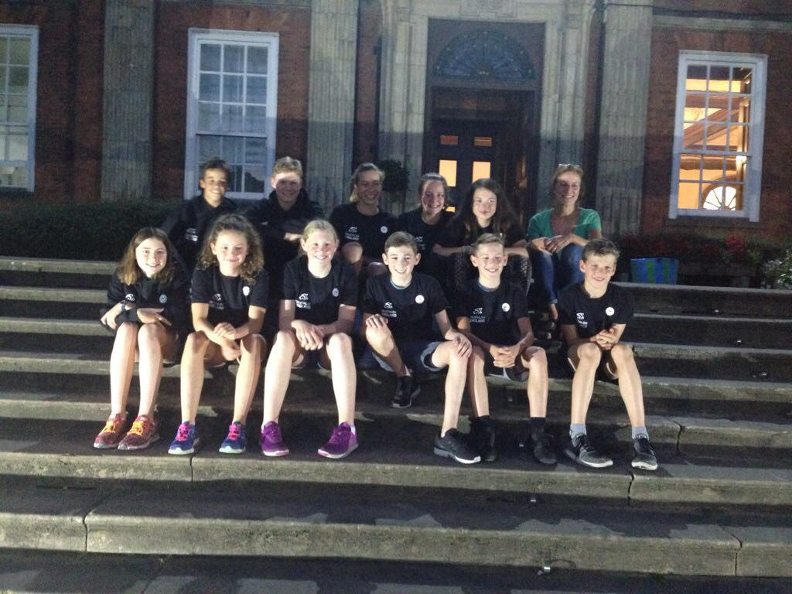

Team Duathlon
2 events of note for the region are scheduled for October. The annual duathlon contest against the SE region (8th October) and the inaugural club duathlon championship (15th October). The later event is also a GO Tri event as the reduced distances for each leg make it easily assessible for new entrants to the sport.

Further Actions for Consideration
- Talk to Trinity organisers to understand their popularity
- Talk to London triathlon team to get feedback on junior participation and plans for next year
- Liaise with other regions during event scheduling to minimise clashes, including Trinity / Eton Dorney
- Liaise with The Bridge to assess whether it is a viable event for the London series next year given the issues raised this year
- Fuller feedback session to see what can be done to improve London IRC performance

Report from Pete Lambert
ROC Report – September 2017 – Peter Lambert
Training
We have three newly qualified Local Technical Officials in the region plus one who is about to complete their on-site training. One LTO has qualified to work as an RTO and another has completed his exam but needs to “shadow” at open water events to complete his training
Events
We are now up to 61 events in the region, all have an official assigned where necessary. We had 88 last year although this included more GoTri events but even so the number is down.
Officials Management System (OMS)
The proposed changes suggested by TE/BTF have not materialised and we are encountering more problems using the OMS, I am told that Eastern region have stopped using it.
Events seem to just appear without any notification, we have to ensure we regularly check the system. Up until recently we were sent a monthly update but quite often this only gave us very short notice to assign an official.
The situation is now compounded by quite slow response times.
TO Meeting
I will be standing down at the AGM but am happy to assist whoever takes over get up to speed, I think a TO meeting sometime in late November would be a good opportunity to introduce the new ROC and review activities in 2017.

Report from Alan Spelling

Senior League

Nine league events completed with full entries, some having to shut early and a noticeable increase in London club participants even from last year.
All league events so far were of a high standard and a credit to each organiser.
We had the Artic One event, counting double points in the Para league, and we have increased the number of para athletes participating.
The “one off” Long Distance London championships were held at The Bridge with some very worth winners who will receive their trophies at the London awards evening.
A few years hard work are paying off and the interest in the league has never been better.
Already we have had a few events clamouring to get provisional dates in for next year and we still have four events to go.
It’s a far cry from the days we persuaded events to be part of the league and its clearly going in the right direction as far as participation and quality events is concerned.

